An innovative Virtual Reality based intrusion detection, incident investigation and response approach for enhancing the resilience, security, privacy and accountability of complex and heterogeneous digital systems and infrastructures.

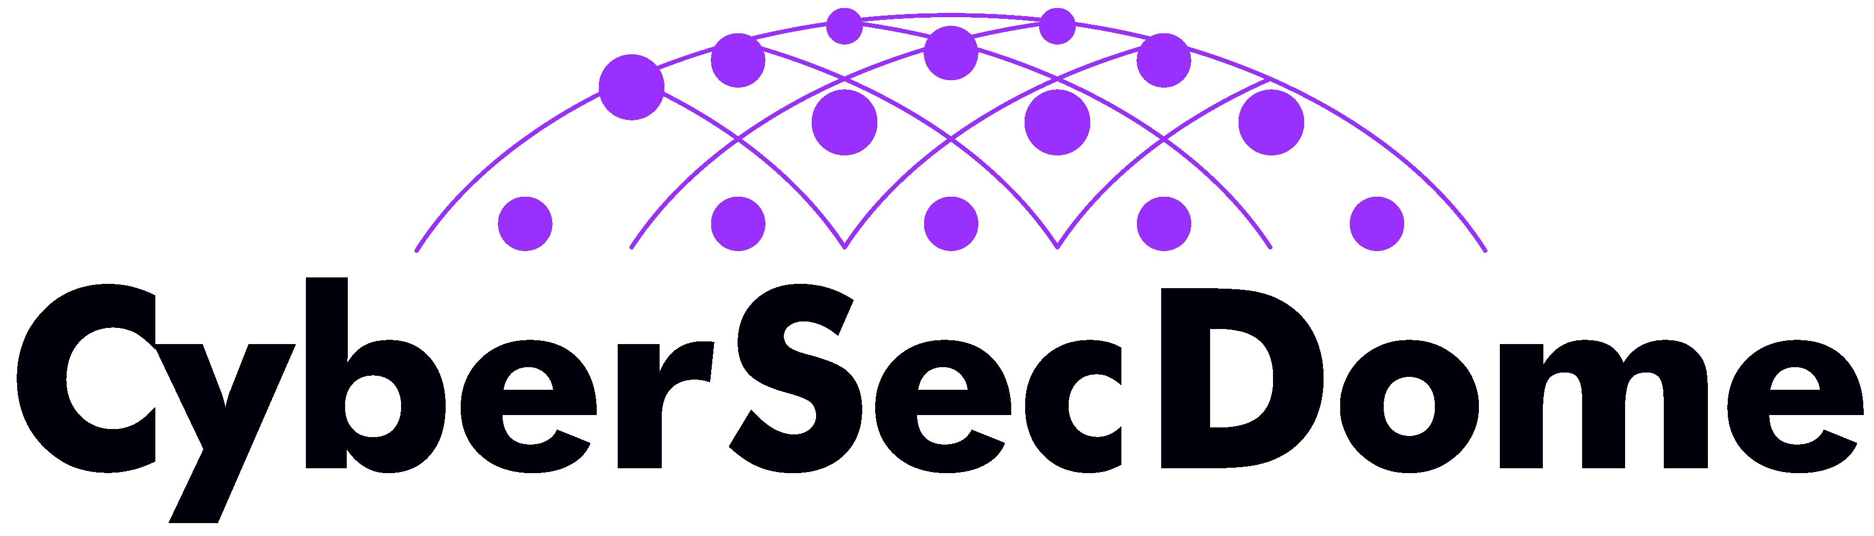
CyberSecDome Open Call Round 2
Proposals Submission Guideline

Table of Contents
1 Introduction 1
2 Documents to Review Before Submission 1
3 Submission Platform 1
4 Proposal Format 1
5 Submission Rules 1
6 Mandatory Proposal Content 2
6.1 Technical Scope & Minimum Requirements for Round 2 Proposals 2
7 Notifications and Results 3
8 Applicant Responsibilities 3
9 Support and Assistance 3
10 Steps for Proposal Submission 3
11 Key Tips for Successful Submission 4

Introduction
These guidelines provide essential instructions for preparing and submitting proposals under Round 2 of the CyberSecDome Open Call. Applicants must follow all instructions carefully to ensure a successful submission and maintain eligibility for funding.

Documents to Review Before Submission
Applicants are highly advised to read the following documents carefully.
- CyberSecDome Open Call General Guide outlines eligibility, evaluation criteria, and key requirements.
- CyberSecDome Round 2 Guide: This focuses on the specific objectives, topic, and expected outcomes of Round 2.
- CyberSecDome Proposal Template for Round 2: This provides the structure and formatting requirements for the proposal.

All documents are available for download on the CyberSecDome website (https://cybersecdome.eu) or upon request via info@cybersecdome.eu and opencall@cybersecdome.eu.

Submission Platform
All proposals must be submitted via the F6S platform at: https://www.f6s.com/cybersecdome-open-call-round-2/. Only submissions through F6S will be accepted. Applicants must register on the platform and complete the required fields within the online form.

Proposal Format
Proposals must be uploaded in PDF format using the official Round 2 Proposal Template available on the CyberSecDome website and the F6S submission page.

The proposal must:
- Be written in English.
- Not exceed 30 pages (excluding annexes).
- Include all sections indicated in the template.
- Use font size 11 (Calibri or Arial recommended).

Submission Rules
- Only one proposal is allowed per applicant or consortium.
- Proposals must focus on the single Round 2 topic.
- No extensions to the deadline will be granted.
- Technical issues must be reported to the Helpdesk at least 2 hours prior to the deadline.
- It is highly recommended to submit proposals well in advance of the deadline to prevent last-minute issues.

Mandatory Proposal Content
Applicants must complete all parts of the Proposal Template:
- General Information
- Proposal Summary
- Applicant(s) Details
- Relevance & Alignment
- Excellence
- Impact
- Implementation
- Cost Effectiveness
- Budget Overview
- Ethical and Legal Considerations

Technical Scope & Minimum Requirements for Round 2 Proposals
To ensure proper alignment with CyberSecDome's objectives and avoid misinterpretations experienced during Round 1, all proposals must clearly demonstrate the following:
- Full deployment and validation of the CyberSecDome integrated prototype, including all key tools and functionalities: AI-enhanced threat detection, VR-enhanced situational awareness, dynamic risk assessment, collaborative threat intelligence modules, etc.
- Definition of a concrete domain-specific use case that complements the existing project pilots in aviation and telecommunications. Priority will be given to proposals from underrepresented sectors such as healthcare, energy, finance, manufacturing, and smart cities.
- Contribution to project KPIs and final validation activities, including structured performance feedback (usability, effectiveness, integration complexity, etc.).
- Willingness to collaborate with the Open Call Implementation Team (OCIT) and technical partners for technical onboarding, platform integration, and monitoring.
- Provision of real-world operational environments and stakeholders for effective demonstration of the platform’s capabilities.
These elements are considered essential and are evaluated under the Relevance & Alignment, Implementation, and Impact criteria. Proposals lacking sufficient clarity or depth on these points may be scored lower during evaluation.

Notifications and Results
Applicants will be informed of the evaluation outcome through the F6S platform and email. Results will include feedback from reviewers and show whether the proposal was chosen for funding.

Applicant Responsibilities
- Monitor the F6S platform regularly for communications and updates.
- Respond promptly to requests for clarification or additional information.
- Ensure compliance with Horizon Europe rules and CyberSecDome eligibility conditions

Support and Assistance
- For queries or assistance during the application process:
  - Email: Reach out to opencall@cybersecdome.eu or info@cybersecdome.eu
  - Social Media: Updates and announcements are shared on:
  - LinkedIn: CyberSecDome LinkedIn
  - X (Twitter): @CyberSecDome_EU
  - YouTube: CyberSecDome Channel
- Submission Platform: For technical issues and/or questions, please contact F6S support at support@f6s.io or opencall@cybersecdome.eu regarding any difficulties you may encounter on the submission platform.

Steps for Proposal Submission
- Registration on F6S Platform:
- Access the CyberSecDome Open Call Round 2 submission page at https://www.f6s.com/cybersecdome-open-call-round-1.
- Applicants with existing F6S accounts can log in directly, simplifying the process. Registration on F6S is not mandatory but is recommended for updates on the proposal status.
- Proposal Preparation:
- Use the Proposal Template provided. Ensure all sections are completed, and supporting documentation (e.g., budget breakdowns, CVs, and letters of commitment) is included.
- Adhere to the formatting and length requirements outlined in the Proposal Template.
- Proposal Submission:
- Upload the completed proposal and additional documents (if required) on the F6S platform.
- Select the relevant topic(s) addressed by your proposal.
- Double-check that all mandatory fields and documents are completed.
- Submission Confirmation:
- Once submitted, applicants will receive an email confirmation with a unique reference number.
- Use this reference number for any correspondence regarding your application.

Key Tips for Successful Submission
- Start Early: Begin preparing your proposal well before the submission deadline to allow time for clarifications or adjustments.
- Read All Materials: Ensure you understand the scope, objectives, and evaluation criteria of the Open Call.
- Ask for Help: Contact the CyberSecDome team for assistance with unclear sections or technical difficulties.
- Review Thoroughly: Ensure compliance with all submission requirements and verify that documents are free of errors.

